**Project Design Phase-II**

**Data Flow Diagram &User Stories**

|  |  |
| --- | --- |
| DATE | 21-10-2022 |
| Project Name | Project - AI based localization and classification of skin disease with erythema |
| Maximum Marks | 4 Marks |

**Data Flow Diagrams:**

A Data Flow Diagram (DFD) is a traditional visual representation of the information flows within a system. A neat and clear DFD can depict the right amount of the system requirement graphically. It shows how data enters and leaves the system, what changes the information, and where data is stored.

**LEVEL 0:**

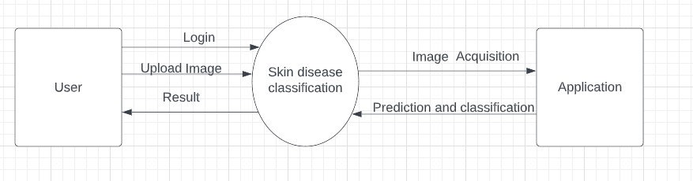

**LEVEL 1:**

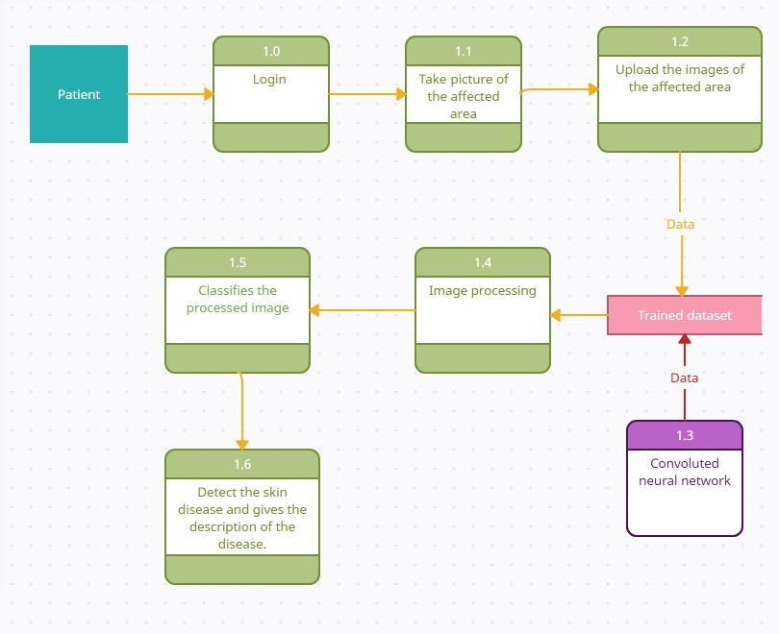

**User Stories**

Use the below template to list all the user stories for the product.

|  |  |  |  |  |  |  |
| --- | --- | --- | --- | --- | --- | --- |
| **User Type** | **Functional**  **Requirement**  **(Epic)** | **User Story Number** | **User Story / Task** | **Acceptance criteria** | **Priority** | **Release** |
| Customer  (Mobile user) | Registration | USN-1 | As a user, I can register for the application by entering my email, password, and confirming my password. | I can access my account / dashboard | High | Sprint-1 |
|  |  | USN-2 | As a user, I will receive confirmation email once I have registered for the application | I can receive confirmation email & click confirm | High | Sprint-1 |
|  |  | USN-3 | As a user, I can register for the application through Facebook | I can register & access the dashboard with Facebook  Login | Low | Sprint-2 |
|  | Login | USN-4 | As a user, I can register for the application through Gmail | I can register through Gmail. | Medium | Sprint-1 |
|  |  | USN-6 | As a user, I can log into the application by entering email & password | I can also receive logout credential. | High | Sprint-1 |
|  | Interface | USN-7 | As a user, the interface should be easy to access. | I can receive login credentia | Medium | Sprint-2 |
| Patient (Web user) | Dashboard | USN-8 | As a user I can specify the information(Skin color,skin tone, skin texture,screening etc) | I can able to know about how depth the disease is. | High | Sprint-1 |
| Patient (input) | View manner | USN-9 | As a user, I can view disease details in visual representation (images). | I can easily understand by using images visually. | High | Sprint-1 |
|  | Color visibility | USN-10 | As a user, I can able to see the skin color due to infected area | I can easily know about the condition of skin color. | High | Sprint-2 |
|  | Knowledge | USN-11 | As a user, I can able to know about the disease details in early stage | I can easily know whether I have disease or not | High | Sprint-1 |
| Administrator | Knowledge | USN-12 | An administrator who Is handling the website should update and take care of the application | Admin should monitor the records properly. | Medium | Sprint-2 |